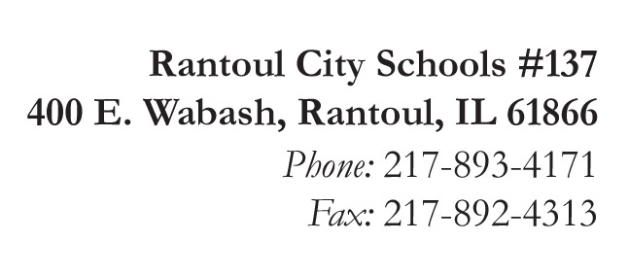
Broadmeadow
Eastlawn
Northview
Pleasant Acres
J.W. Eater

Michelle Ramage
Superintendent

Jennifer Frerichs
Assistant Superintendent

GROW BEYOND!

Rantoul City Schools Dispute Resolution and Complaint Procedures
for McKinney-Vento Homeless Education Programs

- Immediately enroll the homeless student in the school preferred by the parents until the dispute is settled. Provide the parent, guardian, or unaccompanied youth with a copy of the educational rights of homeless students.

- The parent/guardian/youth MUST be referred to the designated LEA homeless education liaison, who is to carry out the dispute resolution as expeditiously as possible.

- The LEA homeless education liaison will discuss the concern or complaint with the Petition and provide the Petitioner with a copy of the District and State Dispute Resolution policy/procedures and all necessary forms for the education of homeless children and youth.

- If the determination is made to deny the student’s homeless status, the LEA homeless education liaison will provide the parent/guardian/youth written notification of the decision.

- The parent/guardian/youth have the right to appeal the decision by completing an Appeal Request Form and submitting it to the LEA homeless education liaison within two (2) school days of this discussion.

- If the Petitioner appeals within the timeline provided above, the LEA homeless education liaison will immediately share all documents with the Regional Office of Education Superintendent, the Area 4 Homeless Liaison and the State Coordinator for Homeless Education. This will include log of phone calls, email messages exchanged and written documentation shared between the Petitioner and the Liaison.

- No later than fifteen (15) school days after receiving the request for review of the appeal, the State Coordinator shall make a final decision regarding the appropriate placement of the student.

- Again , please note, while the appeal is being resolved, the child/children in question MUST REMAIN ENROLLED IN, ATTENDING AND FULLY PARTICIPATING in the school initially requested until all levels of the appeal are resolved.

