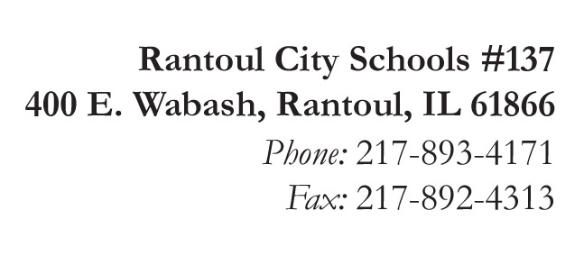
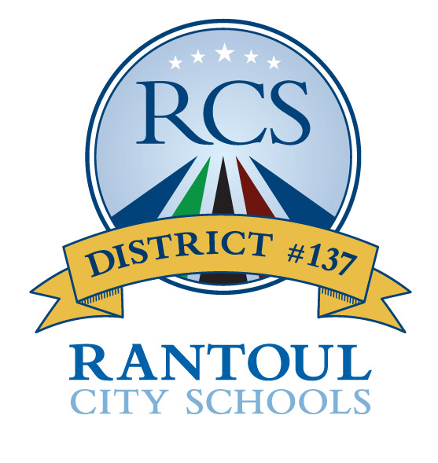
Broadmeadow
Eastlawn
Northview
Pleasant Acres
J.W. Eater

Michelle Ramage
Superintendent

Jennifer Frerichs
Assistant Superintendent

GROW BEYOND!

McKinney-Vento Program Complaint Form – PARENT/GUARDIAN/YOUTH

Date of Complaint __________________ Date of Incident Prompting Complaint: ______________

Person completing complaint form: _____________________________________________________

Student(s): ________________________________________ Grades: ______________________

Relationship to student(s), or self, if unaccompanied youth: __________________________________

I may be contacted at (phone or email): __________________________________________________

Name of School, District and Staff Role Involved: __________________________________________

__________________________________________________________________________________

Please provide a brief, clear explanation of the incident which prompted this complaint.

______________________________________________________________________________________________________________________________________________________________________________________________________________________________________________________________________________________________________________________________________________________________________________________________________________________________________________________________________________________________________________________________________________________________________________________________
(Please include additional pages if necessary.)

___ (initial) The school staff offered to submit this complaint form to ISBE on my behalf.

___ (initial) I have elected to submit this form on my own behalf to ISBE.

SUBMIT THIS FORM TO:

Illinois State Board of Education
Attention: Vicki Hodges, State Coordinator for Homeless Education
100 North First Street, 2000 S-493, Springfield, IL 62777
vhodges@isbe.net

A copy of our state’s dispute resolution procedure for students experiencing homelessness is attached.
You may contact the National Law Center on Homelessness and Poverty for additional information on the McKinney-Vento Homeless Assistance Act (www.nlchp.org) You may also seek the assistance of advocates or an attorney.

