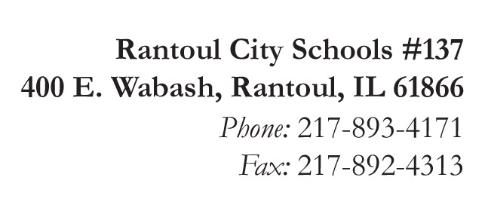
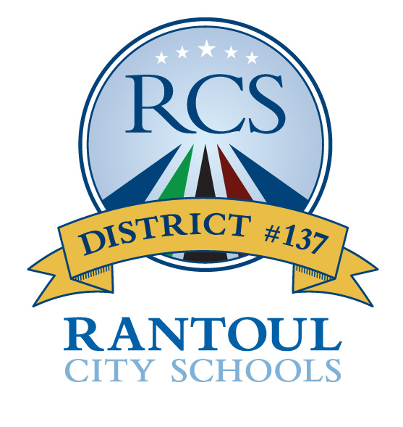
Broadmeadow
Eastlawn
Northview
Pleasant Acres
J.W. Eater

Michelle Ramage
Superintendent

Jennifer Frerichs
Assistant Superintendent

GROW BEYOND!

Written Notification of McKinney-Vento Appeal Request – PARENT/GUARDIAN/YOUTH

Date of Appeal: ____________________ Date of Decision Being Appealed: __________________

Student(s): ___________________________________________ Grades: ______________________

Person completing appeal form: ________________________________________________________

Relationship to student(s), or self if unaccompanied youth: ___________________________________

I may be contacted at (phone or email): __________________________________________________

I wish to appeal the enrollment decision made by: __________________________________________

Name of School and District: __________________________________________________________

I have been provided with (please check all that apply):

___ A written explanation of the school’s/district’s decision

___ The contact information of the District’s MV Liaison

___ A copy of the District or State’s dispute resolution process for students experiencing homelessness

Optional:

Please include a brief, clear explanation of the reason(s) you wish to appeal this determination.
__________________________________________________________________________________________________________________________________________________________________________________________________________________________________________________________________________________________________________________________________________________________________________________________________________________________

___ (initial) The school provided me with a copy of this form upon submission.

SUBMIT THIS FORM TO:
Illinois State Board of Education
Attention: Vicki Hodges, State Coordinator for Homeless Education
100 North First Street, 2000 S-493, Springfield, IL 62777
vhodges@isbe.net

A copy of our state’s dispute resolution procedure for students experiencing homelessness is attached.
You may contact the National Law Center on Homelessness and Poverty for additional information on the McKinney-Vento Homeless Assistance Act (www.nlchp.org) You may also seek the assistance of advocates or an attorney.

