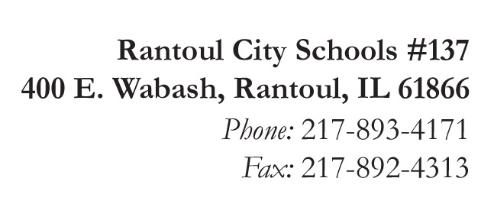
Broadmeadow
Eastlawn
Northview
Pleasant Acres
J.W. Eater

Michelle Ramage
Superintendent

Jennifer Frerichs
Assistant Superintendent

GROW BEYOND!

Written Notification of McKinney-Vento Determination – DISTRICT FORM

To be completed by the McKinney-Vento Liaison when a request for a student experiencing homelessness is declined by Rantoul City Schools #137. This form will be completed and forwarded to the Regional Office of Education Superintendent and the State Coordinator for Homeless Education.

Date of Notification of Determination: ___________________________________________________________________

Person completing form: ______________________________________________________________________________

Title of person completing form: ________________________________________________________________________

In compliance with section 722(g)(3)(E) of the McKinney-Vento Homeless Assistance Act, the following written notification is provided to:

Name of Parent(s)/Guardian(s): _________________________________________________________________________

Name of Student(s): __________________________________________________________________________________

_____ Check here if student is an unaccompanied youth.

After reviewing your request to enroll/serve the student(s) listed above, the request is declined. This determination was based upon the following (attach additional pages if necessary):
_________________________________________________________________________________________________________________________________________________________________________________________________________________________________________________________________________________________________________

You have the right to appeal this decision by completing the second page of this notice or by contacting the school district’s McKinney-Vento Liaison (in person, by email or U.S. mail).

Name of District McKinney-Vento Liaison: _______________________________________________________________

Phone: _____________________________________ Email: ___________________________________________

In addition:
- The student listed above has the right to enroll immediately in the requested school pending the resolution of the dispute.
- You may provide written or verbal communication(s) to support your position regarding the student’s enrollment/service in the requested school. You may use the attached form for this notification.
- If further help is needed or desired you may contact our State Coordinator for Homeless Education:
Vicki Hodges
100 North First Street, 2000 S-493, Springfield, IL 62777
vhodges@isbe.net

A copy of our state’s dispute resolution procedure for students experiencing homelessness is attached.
You may contact the National Law Center on Homelessness and Poverty for additional information on the McKinney-Vento Homeless Assistance Act (www.nlchp.org) You may also seek the assistance of advocates or an attorney.

