Awareness: The Basics
- Contacted Carle Mobile Health Clinic to come do physicals and immunizations for our students that were struggling to get to a doctor. This included our homeless students. Carle along with Champaign-Urbana Public Health came to our district on August 12, 2019 to provide this free service to our families. They saw almost 90 students that day. At that time it was the largest one day mobile clinic that Carle/CUPHD had done. This was advertised to our families via email, phone blasts and personal phone calls. This information was also communicated to the Community Service Center of Northern Champaign County here in Rantoul to give to any families that they work with that were in need of this service.
- Update - Carle Mobile Clinic comes to our district twice a year, April and July to do physicals and immunizations for students and basic health care. They are also in Rantoul the first Monday of every month to do the same services. This is free of charge for families.
- Our McKinney Vento Homeless Rights posters are posted near the entrances of our schools where parents come in to register their students. We have 5 schools and each school has a poster in English and Spanish posted.
- I attended the McKinney-Vento Act Training on August 30, 2019 at our local ROE office. At that meeting we were provided United Way 211 brochures and Healthy Beginnings brochures for health services. I brought these flyers back and distributed them to our social workers who are in the buildings with the students and see the families before I do.
- Update - I attend homeless training each year.
- I had my annual enrollment meeting with secretaries on August 13, 2019. At this meeting I go over with the secretaries their role in making sure homeless students are enrolled immediately, to complete the ISBE McKinney-Vento Homeless Education Common Form and send to me so I can make sure they are reported to our ROE and entered into SIS. If there are specific items that the family is need of I will set up shopping trips to Wal-Mart, set up busing or cabbing to and from school if necessary, help the families contact shelters if needed. Schools supplies are given to the students.
- Update - I do annual homeless training for the district.

Policies and Procedures (ESSA 2018)
- Board Policy:
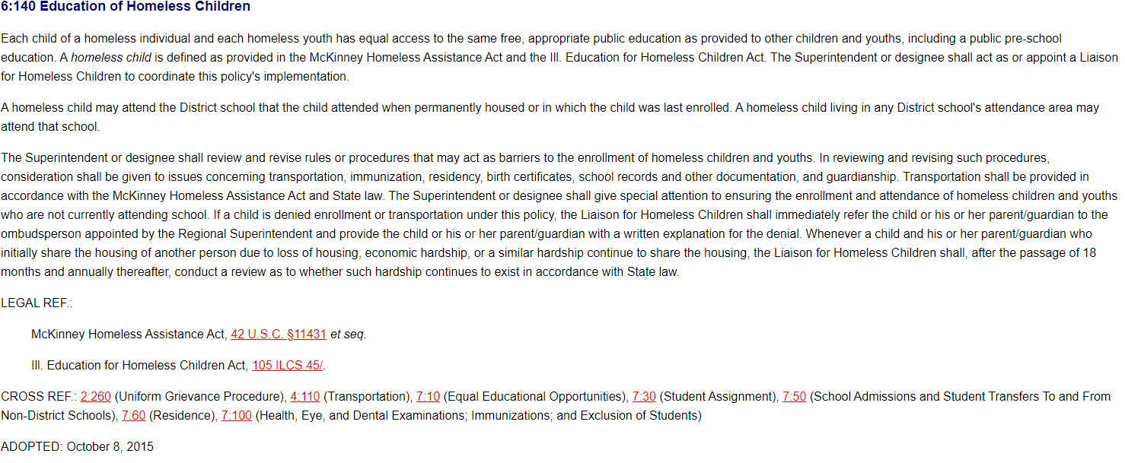
- Information from our Student/Parent Handbook:
HOMELESS CHILD’S RIGHT TO EDUCATION When a child loses permanent housing and becomes a homeless person as defined at law, or when a homeless child changes his/her temporary living arrangements, the parent or guardian of the homeless child has the option of either; 1. continuing the child’s education in the school of origin for as long as the child remains homeless or, if the child becomes permanently housed, until the end of the academic year during which the housing is acquired; or 2. enrolling the child in any school that non-homeless students who live in the attendance area in which the child or youth is actually living are eligible to attend. If you need more information please contact the office in person or call 893-5400

- Our current procedures related to homeless children and youth include the following:
  - New students are enrolled automatically without the need of proof of residency, physicals, immunizations, birth certificate, etc.
  - For new and existing students when we are made aware that a student is homeless the either the registrar or social worker will complete the ISBE McKinney Vento Common Form and send to Darcy Widener. Darcy will then forward a copy to the ROE and put the information in SIS.
  - We then evaluate family to determine their current needs:
    - If the family is in need of housing assistance we encourage them to call 211 or we get them in contact with shelters in the county.
    - We ask if there are students in the family between the ages of 3-5 that we could enroll in our pre-k program.
    - We contact the previous school to see if we can obtain records as soon as possible to make sure we are enrolling the student in the correct programs, IEP, etc.
    - If the child is in need of a physical or immunization we work with the family to assist them with getting appointments and if necessary pay for any uncovered expenses related to school required items.
    - If the family reports they are needing clothing, we arrange with our local ROE for the family to go to Wal-Mart to get necessities for school.
    - If the child is needing transportation to school, setting up bussing or cabbing if necessary. Working with other school districts to split the cost when necessary. Giving gas cards to families if needed.
    - Assist the family in enrolling the child in our after school program or the Boys and Girls Club program.
    - Give students school supplies.
Identification
- Our McKinney Vento Homeless Rights posters are posted near the entrances of our schools where parents come in to register their students. We have 5 schools and each school has a poster in English and Spanish posted.
- Posters are also placed in our pre-k office and our central office.
- We have NCHE parent booklets in English and Spanish to give to parents
- We have enrollment foldouts (Enrollment: Ready Reference for Schools) given to each registrar at each of our schools. Along with sample questions to ask.
Transportation (ESSA 2018)
- Busing will be provided by First Student. They will put students on existing routes to get them to their school of origin.
- If the student requires cab transportation, i.e. is staying in another district, we will contact Yellow Cab in Champaign. We will split the cost with the other district.
- Provide parents with gas cards if other options are not available.
Hotel/Motel Emergency Stays
- We can provide a 3 night emergency stay at a hotel for families who find themselves with nowhere else to stay.
Professional Development
Training will be provided at Principal meetings, Secretary Meetings and with Social Workers annually by the Homeless Liaison.

