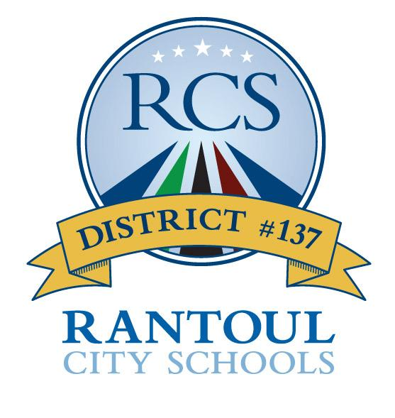
Rantoul City Schools #137
400 E. Wabash, Rantoul, IL 61866
Phone: 217-893-5400
Fax: 217-892-4313

2020-2021 School Year Calendar

Arrival and Dismissal Times
- PreKindergarten (PreK) Half Day (snacks only): AM session: 7:50-10:20 PM session: 11:50-2:20
- K-5th Grade Student Hours: 7:40-2:30
- J.W. Eater Jr High Student Hours: 8:05-3:05

- ½ Day Student Dismissal Fridays: Aug 28, Sept 25, Oct 30, Dec 4, Jan 29, Feb 12, May 7, May 21
  - K-5: 11:00am; Jr. High: 11:30am; No PreK Attendance AM or PM

Aug 11, 12 Teachers’ Institute (No Student Attendance)
Aug 13 First Day of Student Attendance (Full Day only for 1st-8th gr)
Kindergarten ONLY ½ Day
Last Name A – L attend 7:40 am – 10: 40 am
Last Name M – Z attend 11:30 am – 2:30 pm
Aug 14 First Full Day for ALL Kindergarten
Aug 17 First Day of Attendance for Pre-K Students
Aug 28 ½ Day Student Dismissal – School Improvement
Sept 7 Holiday Observance – No School
Sept 25 ½ Day Student Dismissal – School Improvement
Oct 8 Full Day Regular Student Attendance
Parent/Teacher Conferences (Thursday Evening Only)
PreK-5th gr: 3:15pm-8:15pm - Jr. High: 3:30pm-8:30pm
Oct 9 No School (Due to P/T Conferences held Thursday Evening)
Oct 12 Holiday Observance – No School
Oct 16 End of 1st Quarter
Oct 30 ½ Day Student Dismissal – School Improvement
Nov 25, 26, 27 Thanksgiving Break – No School
Dec 4 ½ Day Student Dismissal – School Improvement
Dec 21-Jan 1, 2021 Winter Break – No School
Jan 4 Teachers’ Institute (No Student Attendance)
End of 2nd Quarter
Jan 5 School Resumes
Jan 18 Holiday Observance – No School
Jan 29 ½ Day Student Dismissal – School Improvement
Feb 12 ½ Day Student Dismissal – School Improvement
Feb 15 Holiday Observance – No School
Mar 5 End of 3rd Quarter
Mar 11 Full Day Regular Student Attendance
Parent/Teacher Conferences (Thursday Evening Only)
PreK-5th gr: 3:15pm-8:15 pm - Jr. High: 3:30 pm-8:30 pm
Mar 12 No School (Due to P/T Conferences held Thursday Evening)
Mar 15 -19 Spring Break – No School
Mar 22 School Resumes
Apr 2 No School
Apr 5 No School
Apr 23 Teachers’ Institute (No Student Attendance)
May 7 ½ Day Student Dismissal – School Improvement
May 21 ½ Day Student Dismissal – School Improvement
End of 4th Quarter

The following dates will vary depending on the number of snow days used or not used:
May 21 Last Day of School Year for students and staff (if NO emergency days are used)
May 28 Last Day of School Year (if all 5 emergency days are used) for staff and students

